Software Requirement Specifications
Deep Packet Intelligence


Submitted by
Muhammad Saeed
Roll No:
S23BINFT1M01193

Submitted to
Dr. Dost Muhammad Khan

Department of Information Technology
Faculty of Computing
The Islamia University of Bahawalpur

Summary
Deep Packet Intelligence (DPI) is an open source Network Analysis Project focused on providing enhanced insight into network traffic based on detailed examination of packets (i.e., the payload), rather than simply relying on information found in packet headers.
Many modern firewalls, IDS systems and other signature-based security tools are easily bypassed using advanced tunneling or encryption methods.
As such, there exists a visibility gap within these environments, creating "blind spots" in terms of identifying illegitimate application usage, and/or possible malicious activities hidden behind legitimate traffic. DPI was developed to address this issue by developing a "smart inspection engine," employing machine learning to perform behavioral analysis of network flows.
The DPI engine does not rely upon static signatures when classifying traffic. Instead it relies upon statistical characteristics, including packet inter-arrival time; payload entropy; and byte distribution patterns.
These statistical characteristics allow DPI to classify applications, identify protocol violations and extract malicious signatures from encrypted traffic, all without requiring decryption of the original traffic. The DPI Framework utilizes a Python-based backend for real-time capture and re-assembly of packets, and for enabling accurate classification at very low latencies via utilization of supervised learning techniques.
Ultimately, this project creates a robust system capable of delivering administrators with the "deep intelligence" needed to optimize bandwidth usage in their networks while providing proactive security measures to protect their corporate networks.

Table of Contents
1. Introduction……………………………………………………………. 4
1.1. Purpose…………………………………………………......... 4
1.2. Scope ………………………………………………………… 4
1.3. Product Perspective………………………………..…….. 5
1.4. User Characteristics …………………………….……….. 6
1.5. Similar apps and systems/Literature Review …… 7
1.6. Proposed Technologies …………………………..……… 9
2. Requirements ……………………………………………………...... 10
2.1. Function Requirements …………………………………. 11
2.1.1. Sign Up …………………………………………………………. 12
2.2. Non-Functional Requirements ………………………… 13
3. Use Cases and Flow of Processes ……………………………… 14
3.1. Use Case 1……………………………………………………. 17
4. References…………………………………………………………..… 21

1.Introductiom
1.1 Purpose
This document is about the Deep Packet Intelligence System. It explains what the system can do and how it works. The system looks at the tiny parts of internet traffic, called packets, to make the network safer and work better. It helps keep an eye on what's happening on the network and makes sure everything runs smoothly. The goal of this document is to clearly say what the system needs to do and how it will do it. When working on a project, it's really important that everyone is on the same page. This guide is here to help make sure all team members, whether you're a developer, supervisor, or stakeholder, have a clear idea of what the system is supposed to do, what features it will have, and what it can't do. It's like a roadmap for the whole project, covering design, development, and testing. By sharing a common understanding of the project, we can work together more smoothly and make sure the system turns out as planned. If we all have the same vision, we can avoid confusion and miscommunication, which will help us succeed in the end. This document will be our reference point as we move forward, helping us make good decisions and stay focused. So, it's crucial that everyone takes the time to read and understand this guide, ensuring we're all striving for the same goals.

1.2 Project Scope
The Deep Packet Intelligence (DPI) System is a smart network monitoring and analysis system that will be able to examine and analyse network traffic in real time in an academic environment. The project will have some key components that will be designed and configured, these are:
• Live packet capture from network interfaces
• Packet analysis on multiple OSI layers (Layer 2 - Layer 7)
• Flow extraction and statistical feature extraction
• Machine learning-based traffic classification
• Rule-based threat detection (signatures)
• Instant alerting of security threats
• Logging of traffic, logs and alerts to a database
• Web-based user interface to view network traffic and system results
• RESTful API for system integration This is a system that is a work in progress, a first step that we can continue to improve. It's meant to be straightforward, user-friendly, and to produce good results to start with. A good part of the idea is to combine examining packets with clever analysis tools to gain more insight into the situation. The system is designed to be modular, so we can add new components or make changes as needed, without having to completely replace the system. This will help to make the system adaptable, while still being easy to use and effective. The idea is to develop something that is effective and delivers good results, but is also flexible and can be changed in the future.
1.3 Product Perspective
The Deep Packet Intelligence system is a unique program designed to demonstrate how well it can analyse a network, looking for threats intelligently. It can be used by itself, but it can also be linked to other network monitoring and security systems. It helps it be even smarter at detecting threats, and provides a more comprehensive security system. It can look very closely at the traffic on the network to detect potential threats and warn the network administrators of a potential issue, so they can fix it quickly to stop any issues. The system can communicate with other security systems, which means it's really helpful in the battle against cyber attacks. It's like having a security guard in the network to keep it secure. What it does is it really looks into the traffic in the network, which means it examines every little bit to see if there's anything dangerous. This allows the network administrators to keep up with the hackers and keep the network secure. It's also great at communicating with other systems, so it's a valuable addition to the network security team. In conclusion, the Deep Packet Intelligence system is a powerful system that can help protect networks from cyber attacks. It can deep-packet inspect traffic, and integrate with other security devices, which can help to protect against cyber attacks. With the help of this system, network managers can sleep a little easier at night, knowing their network is safe and sound. Our network defender is always on guard. It monitors data packets as they pass through some threads of the network, examining them in real time. And it's unique because it employs powerful technologies such as machine learning and rule-based matching to make decisions. That means it can detect unusual behaviours or potential security threats, and raise alarms to help you identify potential problems. It uses traditional packet inspection approaches to make them faster and better, and to create a more secure system. So you can be more certain that your network is able to spot and stop potential issues, and that your data and systems are protected. It's as if a security expert is watching out for your network, sounding an alarm if he spots anything unusual. With this type of security, you can rest assured that you can concentrate on the work at hand. The network watchdog is working for you 24/7, protecting and securing your network. In a more abstract sense, our system can be considered as an "actual representation" of corporate solutions such as Intrusion Detection Systems (IDS) and Network Traffic Analyzers. It interacts with:
• Network Interfaces: to sniff traffic
• Processing Engine: to read packets, extract features and perform analysis
• Detection Engines: machine learning, and/or signature matching
• Database/Storage: to store logs, traffic data, and alerts
• Visualization (Web Dashboard): to view and monitor And you can connect to other systems if you need to, via something called a REST API. That's helpful if you want to integrate with other systems, such as security information and event management (SIEM). This tool is designed to run a on a computer system, such as one running Linux. It doesn't have any special hardware requirements. In short, it's an example of how to intelligently inspect data packets, from a standpoint of the way computers and networks are protected against cyber attacks today.
1.4 User Characteristics
Developed for people with various levels of networking and cybersecurity knowledge, the Deep Packet Intelligence system will be used by a variety of different users. The system will be used by a number of users:
• Network Administrators: Those that have moderate to advanced network knowledge (e.g., TCP/IP, routing, protocols). They will work with the system to track network traffic and flows, to monitor and ensure network security.
• Security Analysts: Network security professionals with a deep knowledge of cybersecurity, intrusion detection, and threat analysis. They will work with alerts, scan for potential security issues and use outputs generated by both signature-based and smart detection.
• Students / Researchers: People with a basic or intermediate understanding of network and programming. They will play with the system to learn, experiment and conduct research that requires knowledge about packet analysis and machine learning for cybersecurity.
• System Developers / Maintainers: Experts in Python, networking libraries and APIs. They will be maintaining, expanding and tuning the system. General User Attributes
• Knowledge of computer fundamentals is necessary.
• Some networking knowledge is desirable.
• Knowledge of cybersecurity tools (packet analyzers, IDS/IPS) is required but not all users need to know them. We want our system to be user-friendly, so that users can just start using it. We want it to be easy to use, and that doesn't require techy knowledge. We want it to be intuitive, so it's easy to use it without having to worry how it works. We want it to be straightforward and user-friendly, so people can easily get the most out of it with as little frustration as possible. We are aiming for simplicity so people can use our system, regardless of whether they're technically savvy or not. This will make it so everyone can use it and benefit, even if they're not a tech wiz. We're doing our best to make our system easy to use, so people can easily navigate and get the most out of it. We want our system to be intuitive, so people can just go ahead and use it and get their job done.for cyber security.

1.5 Related Applications & Systems / Literature Review
There are some great tools that can help us keep our networks secure. Deep Packet Intelligence systems work together with other tools such as Deep Packet Inspection and Intrusion Detection/Prevention systems. These tools are really useful in modern networks because they can help us understand the traffic and monitor security. Using these tools helps us understand what's happening in our networks, and protect them from threats. This is important because it protects our networks from all kinds of threats and ensures that they work properly.
Similar Applications and Systems
Many tools and systems exist that perform similar operations to our proposed Deep Packet Inspection system.
Snort:
An open, network security platform can inspect traffic in real time, and will log every packet that is sent between two systems. It has rules (a filter) that check if there's any malicious traffic. This is called signature-based detection because it looks for malicious signature patterns. It's similar to having a security guard that scans every piece of data and compares it to known threats. If it does, it will alert the system and block it. This helps keep the network secure. The system stays vigilant in searching for new attacks, so it can teach itself to detect the newest malicious traffic. It's a vital tool to manage network security and prevent cyber attacks.

Suricata:
A high performance multi-threaded IDS/IPS engine with protocol identification support and Snort rule support. It has packet capture, protocol decoding, detection and output modules. ( MDPI)
Wireshark:
A network protocol analyzer capable of conducting in-depth inspection of packet information of many layers, primarily intended for analysis and troubleshooting tasks.
nDPI:
An open-source library that classifies traffic based on the packet headers and the packet payload; it is commonly employed for traffic analysis. ( MDPI)
These examples show packet sniffer, protocol parser, pattern matching and traffic classification which are used in the proposed Deep Packet Intelligence system.

Literature Review
Academic literature has explored Deep Packet Inspection extensively as a critical aspect of network security and traffic control.
• DPI allows in-depth inspection of packet payload, facilitating identification of applications, malicious software and user activities. ( ScienceDirect)
• Conventional DPI techniques use signature-based matching, in which packet content is compared with a pre-defined pattern or rule to identify threats. ( ResearchGate)
• One study found that Deep Packet Inspection (DPI) systems work by sniffing (listening) data packets to re-assemble them into traffic flows, and then using sophisticated processes to detect patterns or anomalies to get real-time insight into the activity of the data.
These days we have a new way of analysing traffic which leverages machine learning techniques to improve it. So we can now get a better idea of what's happening with traffic and discover new types of threats. It's a big step up from the previous rule-based systems. These systems didn't work well as they could only find what they knew about. But since we have machine learning, we can learn more about the traffic and what's unusual. This allows us to better identify threats and be more secure. We can get into the traffic in more detail and spot security problems we might miss. That's important because it means we can be more secure from cyber attacks and other threats.
The research also shows that there are challenges in managing high-speed traffic, covert protocols and ensuring that networks function efficiently as they scale up.

Conclusion
We have many excellent systems for DPI and intrusion detection (such as Snort and Suricata) and recent research has gravitated towards using intelligence in DPI systems (machine learning).
The Deep Packet Intelligence system builds on these systems, using a combination of:
• Signature-based detection
• Protocol analysis
• Machine learning-based classification
to build a smarter, more efficient and dynamic network monitoring system that meets the challenges of modern cybersecurity.

1.6 Proposed Technologies
The proposed Deep Packet Intelligence (DPI) System will be built with a mix of modern software development tools, networking libraries and smart data processing technologies to provide optimal packet handling performance and threat detection capabilities.
Core Technologies
Python:
Used as the main technology for developing the system because of its ease of use, versatility, and capabilities with regards to networking and machine learning.
Scapy:
A Python library for packet capture, manipulation and protocol inspection.
Machine Learning Technologies
Scikit-learn:
This is used for building machine learning models (Random Forest) for traffic classification.
TensorFlow / Keras (Optional):
Used for implementing deep learning solutions such as LSTM for traffic behavior prediction.
Web and Visualization Technologies

Flask / FastAPI:
I collaborated in the development of the server which does the back-end heavy lifting and the API through which the different parts of the system communicates with each other.
HTML, CSS, JavaScript:
These are used to create the web-based dashboard.
Chart Libraries (e.g., Chart.js):
Used to render traffic data, alerts and trends.
Database Technologies
SQLite / PostgreSQL:
Data storage and logging of data and system flags and outputs.
Networking and System Tools
Libpcap / Npcap:
Provides low-level network access.
Linux Environment (Preferred):
This is the preferred platform for developing and testing code due to its strong support for many tools that help with networking and packet capturing which make it simpler to create and analyse traffic.
Integration and APIs
REST API:
It allows computers to communicate with other systems, such as security information and event management systems and extends the system to provide additional features

2. Requirements
Here, we shall present the functional and non-functional requirements for the Deep Packet Intelligence (DPI) system. Functional requirements define system features and behavior; non-functional requirements define system quality, performance and constraints.

2.1 Functional Requirements
The system shall provide the following functions:
FR-1: Packet Capture
Real time packet capturing shall be provided from one or several network interfaces. Users shall be able to stop and restart packet capturing.

FR-2: Protocol Analysis
It shall provide analysis of captured packets based on the OSI layers (Layer 2 - 7) and protocol types such as Ethernet, IP, TCP, UDP, DNS, HTTP/HTTPS, FTP and SMTP.
FR-3: Flow Generation and Tracking
It shall cluster packets into flows by source/destination IP addresses, protocols and ports. It shall track the duration and activity of flows.
FR-4: Feature Extraction
It shall calculate features on network flows, which include:
Packet count
Byte count
Flow duration
Inter-arrival time
FR-5: Traffic Classification (Machine Learning)
The system shall identify network traffic by using pre-trained machine learning algorithms (e.g. Random Forest, LSTM) as:
Normal traffic
Suspicious or malicious traffic
FR-6: Signature-Based Detection
The system shall identify well-known malicious activity using rules similar to those in Snort and Suricata.
FR-7: Alert Generation
The system shall produce real-time alerts on identified suspicious or malicious activity. Alerts shall include:
Timestamp
Source and destination IP
Protocol
Threat type
FR-8: Data Logging
The system shall capture the traffic, logs and alarms for storage in a database for reporting purposes.
FR-9: Dashboard Visualization
The system shall include a web page dashboard that shows:
Real-time traffic statistics
Active network flows
Alerts and logs
Graphical trends and analytics
FR-10: User Interaction
The system shall allow users to:
Start/stop monitoring
Filter and view traffic data
View alerts and logs
FR-11: REST APIs
The solution shall offer RESTful APIs for integration with other systems like SIEM tools.
2.1.1 Register (Sign Up)
Requirement ID: FR-12
Actors: Admin, Security Analyst, Network Administrator
Description
Users shall be able to sign up and create accounts, with administrator approval.
Inputs
Full Name
Email (must be unique)
Password (at least 8 characters long with alphanumeric and special characters)
Role (Admin / Analyst / Network Administrator)
Profile Picture (optional)
Process
User fills out form
Admin approves/rejects request
Outputs
Account creation confirmation
Access granted and user enabled
5. Non-Functional Requirements
5.2 Reliability
•Packet captures shall automatically restart in the event of NIC failures.
•No more than 5% of packets shall be lost at peak traffic (100 Mbps).
•The database shall be backed up every day and 7 backups will be stored.

5.3 Security
•The dashboard shall communicate via HTTPS (TLS 1.2+) in production.
•The API shall be protected by tokens (JWT) for insert operations.
•Raw packet data with user passwords or personal data shall not be stored in the database in plaintext.
•Only system administrators shall have access to raw PCAPs.

5.4 Maintainability
•The source code must adhere to Python (PEP 8) and JavaScript (ESLint) guidelines.
5.5 Portability
- The core capture and analysis engine shall run on Ubuntu 22.04 LTS and Kali Linux 2024.x without modification.
- The dashboard shall render correctly on Chrome, Firefox, and Edge (latest two major versions).

5.6 Usability
- A first-time user with basic networking knowledge shall be able to start a live capture within 5 minutes of reading the Quick-Start guide.
- All error messages shall include a human-readable description and a suggested remediation step.

Use Cases and Flow of Processes
Use cases illustrate interactions between users (actors) and the Deep Packet Intelligence (DPI) System to achieve certain goals. They are a visual representation of system behavior based on functional requirements and give insight into system behavior in different contexts.
System-level use cases describe the interactions of users with the DPI system to perform traffic monitoring, threat detection, analysis of alerts and system administration.
Primary Actors
Admin
Network Administrator
Security Analyst
IT Manager
System Developer
Main Use Cases

1.User Registration & Login
Actors: Admin, Security Analyst, Network Administrator
Description: Users create accounts and login to use features depending on their roles.
2. Configure System
Actors: Network Administrator
Description: Define interfaces, rules and thresholds.
3. Update Signatures
Actors: Network Administrator
Description: Update rule-based signatures for traffic.
4. Monitor Live Traffic
Actors: Security Analyst, Network Administrator
Description: Monitor live packet and traffic capture.
Includes:
Analyze Alerts
Investigate Incidents
5. Analyze Alerts
Actors: Security Analyst
Description: Review and investigate system alerts.
6. Investigate Incidents
Actors: Security Analyst
Description: Conduct thorough analysis of incidents.
7. Generate Reports
Actors: IT Manager
Description: Create notifications based on traffic and alerts.
Includes:
Manage Users (RBAC)
Integrate via REST API
8. Manage Users (RBAC)
Actors:
Admin Description: Assign user permission.
9. Dashboard Visualization
Actors: All Users
Description: Get visual display of traffic data and alerts
10. API (REST)
Actors: System Developer
Description: Offer REST API to other systems.

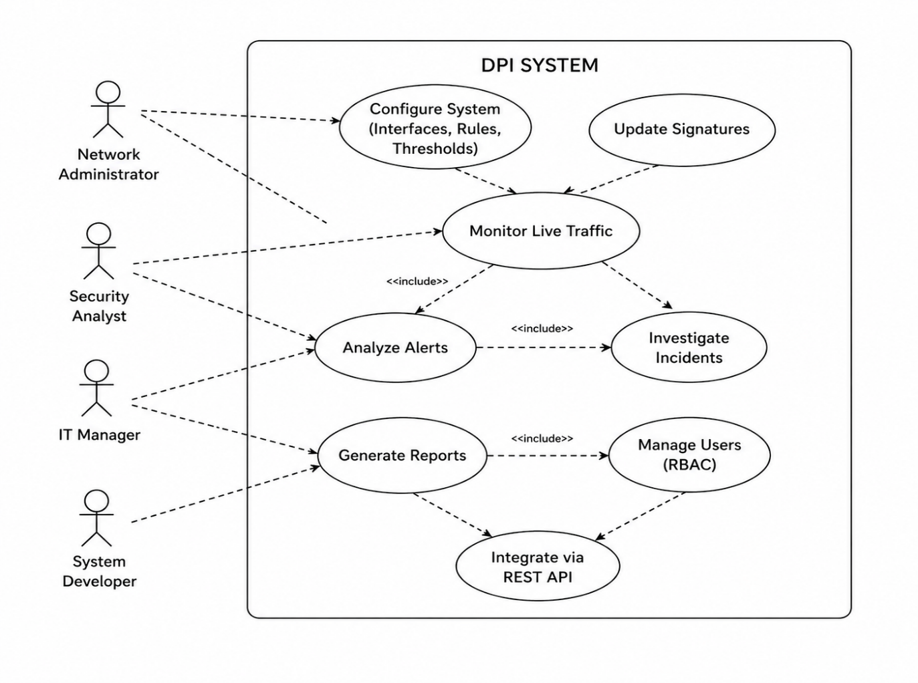

Packet Processing flowchart
This illustrates how the Deep Packet Intelligence (DPI) System captures, processes and responds to network packets.
1. Start Capture
It all starts when a user starts capturing packets from the dashboard.
2. Capture Packet (from NIC/PCAP)
packets from: Network Interface Card (NIC) from network
PCAP files for offline analysis
3. Decode Packet (Layer 2 - 7)
The program decodes packet headers and contents of the OSI layers:
Layer 2: Ethernet
Layer 3: IP
Layer 4: TCP/UDP
Layer 7: Application (HTTP, DNS, ...)
4. Reassemble Stream (if TCP)
If the traffic uses TCP:
The data is put back together
This allows to work with sessions rather than packets
5. Classify & Analyze
The system does deep analysis using:
Signature-based (known threats)
Heuristic analysis (rules/behavior)
Machine Learning (unknown threats)
6. Decision: Possible Threat / Policy Violation?
7. Generate Alert
An alert is created containing:
Source/Destination IP Protocol Threat type Timestamp
8. Send Notification
Alerts are sent via: Email Webhooks (integration to other systems) 9. End The end of the process for that packet/flow System continues monitoring

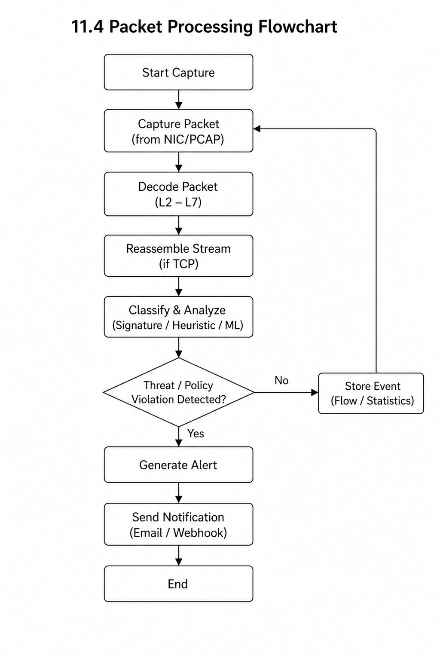

Alert Generation Flowchart
This is a flowchart for alert generation .
1.Event / Detection Received
The system receives:
Detection from packet processing
Suspicious event or anomaly
2. Match Against Rules
The system looks for a match to rules (signatures)
3. Decision: Match Found?
No Match
The system:
Logs the event
No alert is generated
Match Found
The system continues to the blocking rules
4. Determine Severity
The system assigns a severity level:
Info
Low
Medium
High
Critical
5. Create Alert Record
Record is persisted in the database
Includes all relevant metadata
6. Display on Dashboard
Alert is displayed in the browser
Users can view it
7. Send Notification
Send notification to users/admin through:
Email
Webhook/API
8. End
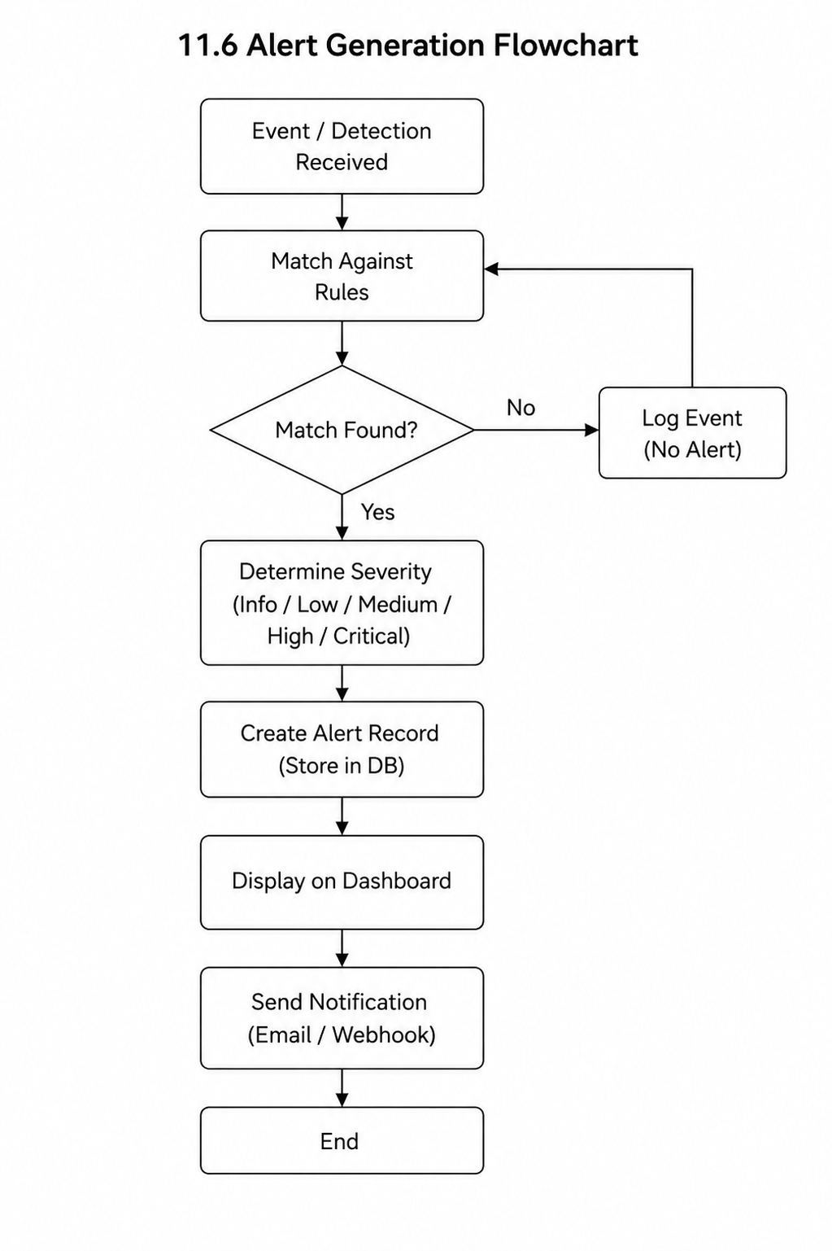
Alert process completes

4.References
[1] Snort, “Snort - Network Intrusion Detection System,” Available: https://www.snort.org
[2] Suricata, “Suricata: Open Source IDS/IPS/NSM engine,” Available: https://suricata.io
[3] Wireshark, “Wireshark Network Protocol Analyzer,” Available: https://www.wireshark.org
[4] nDPI, “nDPI Deep Packet Inspection Library,” Available: https://www.ntop.org/products/deep-packet-inspection/ndpi/
[5] Scapy, “Scapy Documentation,” Available: https://scapy.net
[6] Scikit-learn, “Scikit-learn: Machine Learning in Python,” Available: https://scikit-learn.org
[7] TensorFlow, “TensorFlow Official Documentation,” Available: https://www.tensorflow.org
[8] Keras, “Keras Documentation,” Available: https://keras.io
[9] Flask, “Flask Web Framework,” Available: https://flask.palletsprojects.com
[10] FastAPI, “FastAPI Documentation,” Available: https://fastapi.tiangolo.com
[11] PostgreSQL, “PostgreSQL Documentation,” Available: https://www.postgresql.org
[12] SQLite, “SQLite Documentation,” Available: https://www.sqlite.org
[13] Libpcap, “Libpcap Packet Capture Library,” Available: https://www.tcpdump.org
[14] Npcap, “Npcap Packet Capture Library,” Available: https://nmap.org/npcap/

